

Data Structures

Experiment (2)

SID： | 242910701126
Name： | TASKIN AHMAD AL FARUQE

《Data Structures》
Title： | The Leaf Counting and the Height of a Binary Tree.
Experimental Environment：
Language: C++
Compiler: g++ / Visual Studio.
Operating System: Windows.
Experimental Content：
- Concept
A Binary Tree is a hierarchical data structure in which each node has at most two children, called the left child and right child.

Leaf Node
A node is called a leaf node if both its left child and right child are NULL.

Height of Binary Tree
The height of a binary tree is defined as the maximum number of levels from the root node to the deepest leaf node.

2.Code (with Comments)

template <class T>
struct BiNode
{
T data;
BiNode<T> *lchild;
BiNode<T> *rchild;
};

#include <iostream>
using namespace std;

template <class T>
class BiTree
{
private:
BiNode<T> *root;

public:
BiTree()
{
root = NULL;
}

// Create binary tree (preorder input, '#' represents NULL)
void Create(BiNode<T> *&node)
{
T ch;
cin >> ch;
if (ch == '#')
{
node = NULL;
}
else
{
node = new BiNode<T>;
node->data = ch;
Create(node->lchild);
Create(node->rchild);
}
}

void CreateTree()
{
Create(root);
}

// Count leaf nodes
int CountLeaf(BiNode<T> *node, int &count)
{
if (node != NULL)
{
if (node->lchild == NULL && node->rchild == NULL)
count++;
CountLeaf(node->lchild, count);
CountLeaf(node->rchild, count);
}
return count;
}

// Get height of binary tree
int Height(BiNode<T> *node)
{
if (node == NULL)
return 0;
int L = Height(node->lchild);
int R = Height(node->rchild);
return (L > R) ? L + 1 : R + 1;
}

// Interfaces
int LeafNumber()
{
int count = 0;
return CountLeaf(root, count);
}

int TreeHeight()
{
return Height(root);
}
};
int main()
{
BiTree<char> T;

cout << "Input binary tree (preorder, # for NULL):\n";
T.CreateTree();

cout << "Number of leaf nodes: " << T.LeafNumber() << endl;
cout << "Height of binary tree: " << T.TreeHeight() << endl;

return 0;
}

Input:
A B D # # E # # C # F # #

Running Result：
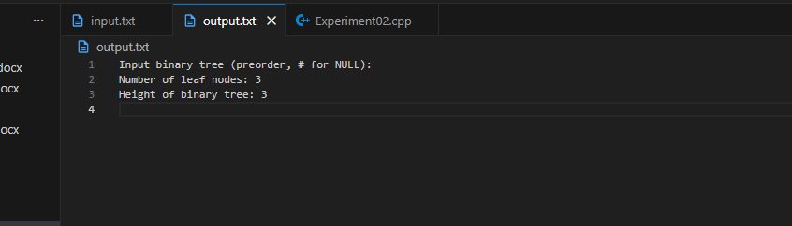

Encountered Problems：
- Handling NULL child nodes
- Correctly identifying leaf nodes

Solutions：
- Use '#' as a sentinel value to represent NULL
- Apply recursive traversal carefully
- Use reference variables to count leaf nodes

